**\*||\*** BrainBoost RestSkill Academy **\*||\***

**Project Management Plan Template**

We are **Team SpyQuad**, a group of passionate individuals dedicated to solving real-world challenges in education through innovative technology.

Our API transforms education by providing personalized and scalable solutions, empowering both students and educators.

Our project represents innovation, inclusivity, and the drive to create lasting change.

Join us as we revolutionize education, one impactful solution at a time!

**Project Management Plan**

**Spy-Quad**

[**S K Somaiya College, Mumbai**](https://sksc.somaiya.edu/)**.**

**members-**

1. PARTH MAHADIK
2. SHASHANK PANDEY
3. SAMEER SHEKH
4. HARIOM

**Date-**

**12-12-2024**

**Table of Contents**

Introduction 2

Project Approch 2

Project Scope 3

Milestone List 3

Schedule Baseline and Work Breakdown Structure 4

Change Management Plan 5

Communications Management Plan 6

Cost Management Plan 8

Rewards………………………………………………………………………………………………… 9

# Introduction

# In the rapidly evolving landscape of education, technology has emerged as a key enabler, transforming how knowledge is delivered, accessed, and applied. However, the adoption of cutting-edge technologies, such as Artificial Intelligence (AI), often poses challenges for both educators and students. Limited accessibility, lack of familiarity, and a steep learning curve hinder their ability to leverage these tools effectively.

# To address these challenges, Team spyquad has developed an innovative API designed to bridge the gap between traditional education methods and emerging technologies. Our solution focuses on empowering teachers and students by making advanced tools more intuitive, accessible, and adaptable to everyday learning scenarios. By simplifying complex technologies, we aim to foster an environment where AI and education coexist seamlessl.

# This report outlines the development and features of our API, emphasizing its potential to revolutionize education. By facilitating ease of use and promoting AI literacy, our project seeks to create a future where technology is not just a tool but a cornerstone of effective teaching and learning.

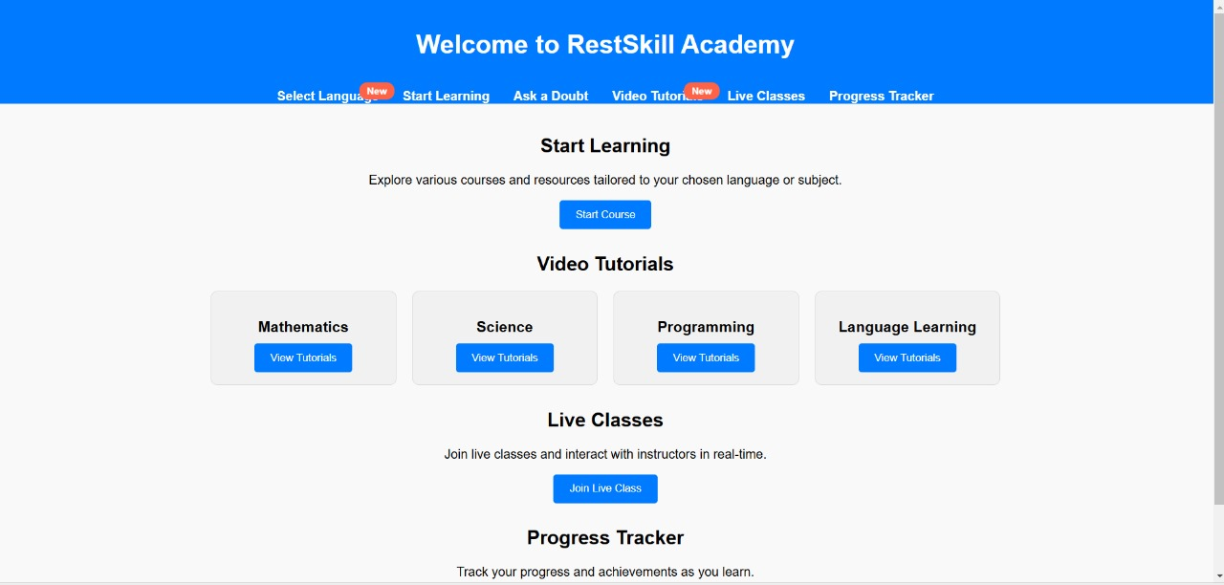

# Project Management Approach

Our approach to this project was centered around creating a fundamental API that lays the groundwork for integrating advanced educational technologies, making them accessible to both teachers and students. The primary objective was to develop a solution that would be intuitive, scalable, and easily adoptable at the beginner level. The following outlines the steps and rationale behind our approach:

1. **Understanding the Problem**  
   We began by analyzing the challenges faced by educators and students in accessing and adopting emerging technologies, particularly AI. Recognizing the need for simplicity and ease of use, we focused on building a solution that could bridge the technological gap without overwhelming users.
2. **Designing a Beginner-Friendly API**  
   The core of our approach was to design an API that covers all the essential aspects of education technology at the foundational level. By starting with basic functionality, we ensured that both teachers and students could interact with the technology in an easy and understandable way. Each feature was developed to provide clear value and purpose, avoiding unnecessary complexity.
3. **Ensuring Clarity and Usability**We prioritized clarity in the design of our API. The meaning and purpose of each feature within the API were thoroughly defined and documented. This allowed for easy comprehension and smooth implementation, ensuring that users could quickly get familiar with the technology without the need for extensive training**.**
4. **Focus on Accessibility and Inclusivity**

Ensuring that the API is accessible to a wide range of users was a crucial part of our approach. We designed the system to be inclusive, allowing users with varying technical backgrounds to adopt it without difficulty. By providing simple interfaces and detailed explanations, we made sure that educators and students from different domains could effectively utilize the technology.

1. **Iterative Testing and Feedback**  
   Throughout the development process, we continuously tested our API with real users—teachers and students—to gather feedback. This allowed us to fine-tune the features and ensure that the final product was both effective and user-friendly. We kept the initial scope simple, with the plan to expand functionality as we gained more insights from the testing phase.

# Milestone List

The future goals of our project are centered around enhancing and expanding the capabilities of our API to better serve educators and students as they navigate the evolving landscape of education technology. We aim to build on our foundational approach and introduce advanced features that will further improve accessibility, AI integration, and the overall learning experience. Below is a list of key areas we plan to focus on in the future development of our project:

|  |  |  |
| --- | --- | --- |
| Milestone | Description | Date |
| Login page/Home Page | Secure login for accessing personalized learning dashboard. | 12/12/2024 |
| Learning platform | A user-friendly platform offering courses, progress, rewards. | 12/12/2024 |
| Quize game | An interactive quiz game for engaging learning. | To be devlope |
| cources | A variety of courses for skill development and learning. | To be devlope |
| Chat box | An AI-powered chatbot for instant assistance and support. | Under devlope |

# 



# Schedule Baseline and Work Breakdown Structure

**Schedule Baseline**

A **Schedule Baseline** is the approved version of the project schedule that includes planned start and finish dates for each task or milestone. It serves as a benchmark for tracking the project's progress and is essential for managing scope, time, and cost.

The schedule baseline for our project includes the key phases and milestones, outlined as follows:

| **Phase** | **Task** | **Start Date** | **End Date** | **Duration** |
| --- | --- | --- | --- | --- |
| **Phase 1: Project Planning** | Define project scope, objectives, and deliverables | 01-Jan-2025 | 07-Jan-2025 | 7 days |
| **Phase 2: Requirements Gathering** | Collect feedback from users (teachers, students) | 08-Jan-2025 | 14-Jan-2025 | 7 days |
| **Phase 3: Design** | Design API architecture and user interfaces | 15-Jan-2025 | 21-Jan-2025 | 7 days |
| **Phase 4: Development** | Develop core features and functionality of the API | 22-Jan-2025 | 11-Feb-2025 | 3 weeks |
| **Phase 5: Testing & Debugging** | Conduct user testing and debug the API | 12-Feb-2025 | 18-Feb-2025 | 7 days |
| **Phase 6: Deployment** | Deploy the API for initial users and collect feedback | 19-Feb-2025 | 25-Feb-2025 | 7 days |
| **Phase 7: Documentation** | Prepare documentation, user guides, and training materials | 26-Feb-2025 | 28-Feb-2025 | 3 days |
| **Phase 8: Feedback & Iteration** | Collect feedback, make adjustments, and prepare future updates | 01-Mar-2025 | 07-Mar-2025 | 7 days |

.

# Change Management Plan

A **Change Management Plan** outlines the process by which changes to the project’s scope, schedule, and resources are managed, ensuring that they are properly evaluated, approved, and implemented. The goal is to maintain the integrity of the project while adapting to any unforeseen circumstances or necessary adjustments.

**1. Purpose and Objective**

The objective of the Change Management Plan is to ensure that any changes to the project are systematically managed and that all stakeholders are informed of the changes. This plan aims to minimize disruptions, maintain project alignment with the original goals, and ensure that any necessary changes are made in a controlled and organized manner.

**2. Change Control Process**

The process for managing changes involves several steps that ensure all modifications are appropriately reviewed, approved, and communicated. The process is outlined below:

1. **Change Identification**
   * **Trigger:** A change request may arise from stakeholders, team members, or external factors (e.g., new technology, regulatory requirements, or unexpected challenges).
   * **Documentation:** The change request should be formally documented, specifying the nature of the change and the impact it may have on the project (scope, timeline, resources, etc.).
2. **Change Impact Analysis**
   * **Review:** The project manager and relevant team members will review the change request to assess the potential impact on project objectives, timelines, costs, and resources.
   * **Assessment:** Determine whether the change is necessary, how it will affect the overall project, and whether it aligns with the project’s goals.
3. **Change Approval**
   * **Stakeholder Involvement:** Once the impact is analyzed, the change request will be presented to key stakeholders, including project sponsors, managers, and affected parties, for approval.
   * **Approval Process:** The decision to approve or reject the change will be made based on the results of the impact analysis. If the change is deemed beneficial, it will proceed to implementation.
4. **Change Implementation**
   * **Execution:** Once approved, the necessary adjustments (whether related to scope, schedule, or resources) will be implemented. The change will be incorporated into the project plan and executed by the designated team members.
   * **Documentation:** The changes will be documented in project records and communicated to all stakeholders to ensure alignment.
5. **Monitoring and Review**
   * **Tracking:** After implementation, the impact of the change will be tracked to ensure that it is achieving the desired outcomes.
   * **Feedback:** Regular check-ins and feedback sessions will be conducted to assess if the change is functioning as expected or if further adjustments are needed.
6. **Final Approval and Closure**
   * Once the change is successfully implemented and its effectiveness is verified, it will be formally closed. Final approval will be sought from stakeholders, and the project will be updated accordingly.

**3. Roles and Responsibilities**

The following roles will be involved in the Change Management Process:

* **Project Manager**
  + Responsible for overseeing the change management process and ensuring that all changes are handled in accordance with the plan.
  + Leads the change impact analysis and coordinates the approval process.
* **Change Control Board (CCB)**
  + A group of key stakeholders (including project sponsors, team leads, and subject-matter experts) responsible for reviewing and approving change requests.
* **Team Members**
  + Responsible for identifying potential changes and providing input into the impact analysis. They will also implement the approved changes.
* **Stakeholders**
  + Includes both internal and external parties who have a vested interest in the project. Stakeholders must be informed of any changes that may affect them.

# Cost Management Plan

**1. Purpose and Objective**

The objective of the **Cost Management Plan** is to provide a systematic approach to managing the project's budget, ensuring financial resources are allocated efficiently, and expenses are tracked accurately. The key goals of the plan are:

* **Effective budgeting**: Ensuring the project is completed within the approved financial constraints.
* **Cost tracking**: Monitoring project costs against the budget to identify discrepancies early.
* **Cost control**: Implementing corrective actions when necessary to keep the project within budget.

**2. Cost Management Process**

The cost management process includes the following steps:

1. **Cost Estimating**
   * **Objective**: Estimate the financial resources required for the project based on the defined scope, schedule, and resources.
   * **Approach**: Use historical data, expert judgment, and standard estimating techniques (e.g., analogous estimating, parametric estimating, bottom-up estimating) to forecast costs.
   * **Deliverables**: Estimated cost for each project phase, task, and resource.
   * **Tools**: Cost estimation software, spreadsheets.
2. **Cost Budgeting**
   * **Objective**: Aggregate estimated costs to develop a detailed project budget.
   * **Approach**: Break down the costs into categories, such as labor, equipment, software, and materials, and assign them to specific tasks or deliverables.
   * **Deliverables**: Detailed budget, including contingency and management reserves, which account for uncertainties.
   * **Tools**: Project management software (e.g., Microsoft Project, Primavera).
3. **Cost Control**
   * **Objective**: Monitor project costs and compare them with the budget to control financial performance.
   * **Approach**: Regularly track actual costs and compare them with the planned budget. Implement corrective actions when variances are identified (e.g., reducing scope, adjusting schedules, reassigning resources).
   * **Deliverables**: Monthly or weekly cost performance reports, updated project budget.
   * **Tools**: Earned Value Management (EVM), project management software.

**Roles and Responsibilities**

Effective cost management involves the participation of several key roles:

* **Project Manager**
  + Responsible for overall cost management, including estimating, budgeting, and controlling costs.
  + Ensures that the project stays within the approved budget by reviewing cost reports and taking corrective actions as needed.
* **Cost Estimator**
  + Specializes in gathering and analyzing data to produce accurate cost estimates.
  + Works closely with the project team to gather the necessary information for estimating project costs.
* **Finance Team**
  + Supports cost estimation, budget creation, and tracking processes by providing financial expertise.
  + Responsible for the disbursement of funds and ensuring the project adheres to financial policies.
* **Project Team Members**
  + Provide input into the cost estimation process, particularly regarding labor and resource costs.
  + Track their own expenses and report any discrepancies or concerns to the project manager.

**4. Cost Breakdown Structure (CBS)**

The **Cost Breakdown Structure (CBS)** is the hierarchical decomposition of costs for the project. It organizes the project’s costs into manageable categories to simplify monitoring and control. Below is an example CBS:

| **CBS Level** | **Cost Category** | **Description** |
| --- | --- | --- |
| **1** | **Project Costs** | Total costs associated with the entire project. |
| **2** | **Labor Costs** | Costs for project team members and external consultants. |
| **3** | **Equipment and Software** | Cost of purchasing and maintaining hardware and software. |
| **4** | **Materials and Supplies** | Cost of physical resources required for the project. |
| **5** | **Contingency Costs** | Funds reserved for unplanned issues or risks. |
| **6** | **Operational and Overhead Costs** | Indirect costs, including utilities and office space. |

**5. Cost Estimation Methods**

The following methods will be used for estimating project costs:

* **Analogous Estimating**
  + Based on historical data from similar projects, this technique provides a rough estimate for cost based on experience.
  + **Example**: Using data from previous API development projects to estimate labor costs for the current project.
* **Parametric Estimating**
  + Uses statistical models to predict cost based on known parameters (e.g., cost per user or cost per feature).
  + **Example**: Estimating costs based on the number of features being developed in the API.
* **Bottom-Up Estimating**
  + Estimates costs for individual work packages and then aggregates them to determine the total project cost.
  + **Example**: Estimating costs for each module of the API and then adding them up.
* **Expert Judgment**
  + Gathering cost estimates from subject matter experts or experienced professionals to get accurate cost projections

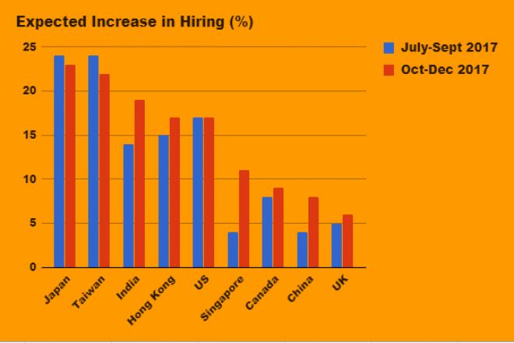

The graph visualizes the relationship between the number of available job roles and the number of job seekers in the market. This comparison provides valuable insights into the demand and supply of jobs in the industry.

The graph can provide insights into particular sectors where job seekers may face difficulties finding roles or sectors that are growing and hiring extensively. For instance, sectors like **healthcare, technology,** or **manufacturing** may show a marked increase in job roles, suggesting a booming job market, while others, like **retail** or **hospitality**, might show fewer roles, reflecting lower demand in those sectors.

**Extended Rewards for Long-Term Commitment**

Objective:  
The system will now offer additional rewards for students who remain committed to courses for longer periods, specifically those who enroll in courses lasting more than two months. This will further motivate students to maintain consistency and progress through extended learning periods.

**Key Updated Features:**

1. **Standard Monthly Consistency Reward:**
   * As previously described, students will receive a **2% discount** at the end of each month for maintaining daily logins without any gaps beyond 24 hours. This reward applies to students who are enrolled in courses for up to one month.
2. **Extended Discount for Longer Enrollment:**
   * For students enrolled in **courses longer than two months**, they will receive an **additional 5% discount** on their total discount after the second month.
   * This means:
     + After completing **one month**, the student gets the **2% discount**.
     + After **two months**, the student gets an **extra 5% discount** on the total, bringing the total discount to **7%**.
     + **The discount percentage continues to increase** as long as students remain consistent and enrolled in courses longer than two months.
3. **Increased Incentives for Continued Engagement:**
   * The **additional 5% discount** ensures that students who engage with the platform over a longer duration are rewarded for their **loyalty and commitment**.
   * This tiered reward system encourages students to **stick with their courses** for longer durations, thus increasing course completion rates.

Benefits of This Extended Reward System:

**1.Encourages Long-Term Commitment:**

* This new feature targets students who enroll in long-duration courses. The more committed they are, the higher the discount they can earn, which further incentivizes students to stay with the platform and continue learning.

2.**Increased Retention and Completion Rates:**

* The 7% (or higher) reward on extended enrollments motivates students to stay on track with their courses, increasing course completion rates. Long-term learners are likely to complete courses successfully when they feel incentivized by extra benefits.

3. **Enhanced User Experience:**

* The tiered reward structure provides a **personalized and rewarding experience** that aligns with the student’s engagement and commitment, making the learning process more enjoyable and engaging.